Active. Confident. Energetic

Women’s Development Cell
Bombay Teachers’ Training College
Presents
TALKFEST ON EDUPRENEURSHIP
On Tuesday, 3rd November 2020
11:00 to 12:30pm

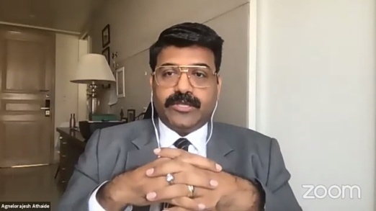
Edupreneurship- A concept that is taking deep roots in the education system. It’s now developing as a culture and a new trend to promote positive essence in the education system all around the world. To give us an insight and explain the true meaning of Edupreneurship, we had on our panel Mrs. Lina Ashar (Founder- Kangaroo Kids Education) and Mr. Agnelorajesh Athaide (Founder- St. Agnelo’s Computers Ltd). The talk commenced by Lina Ma’am explaining the meaning where she highlighted that any new Innovation, the Integration of Technology, New Ideas, New concepts and Different trends that is brought in the intersection of Education and Academics is called as Edupreneurship. Mr. Agnelo mentioned that competition in edupreneurship is not between schools, companies, curriculums but it is the competency that lies between two persons. Edupreneurs are the ones that uphold essential capability and skill sets that they use to grab opportunities and seek for global trends, different trends that are accepted globally. Now there is no time for Brain-Drain, we need innovation that this generation demands. Creating an impact with your innovation in education is the true achievement of Edupreneurship.

Mrs Lina shared a very interesting story of herself where she had to being about a change in her teaching methodology while she was teaching a group of young boys who belonged to a relatively low socio-economic households. Her focus and need was only to get those young minds engaged and involved in the thinking- learning process. Mr Agnelo stressed upon a very crucial new term Passion-preneurship- where passion is the driving force in the attainment of the goal, profits and earning you wish to achieve. Both the panellist stressed upon on major element that is passion is the missing element, it is impossible for a person in the education background to transform him/herself as an Edupreneur. The urge and the need to create an impact is a self driven and an internal idea. Eg- In today’s times the intersection or rather integration of Expressive Arts, Technology, Music, Research etc are all the impacts that the edupreneurs have brought about in the education system. Each One – Reach One is a collaborative idea where each one of us can help one person in our community and encourage them towards education. Dr. Lina quoted that we all need to be good story tellers, there will be people who will join your journey, if your story is picked up it is going to be a ripple effect and in turn creating a bandwagon.

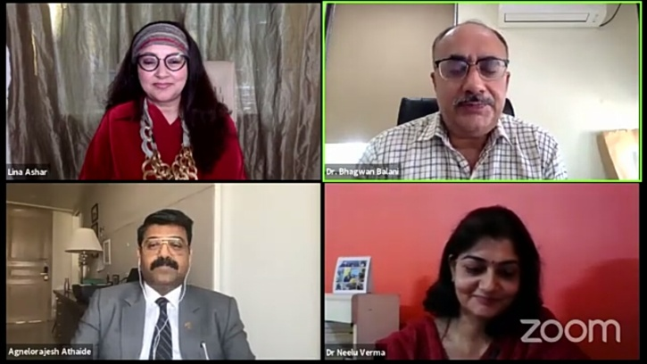
Mr. Agnelo said that our purpose, Our “Why” has to be impactful. Money, profits etc are not important but you will has to be. There are many such stories that denote a individual achieving great heights without having luxuries, what we need is the “Will.” Mr. Agnelo mentioned the important P’s- Pain, Proof, Promise, and Purpose. (Finding out the Pain areas in the society, Promise to resolve or render help for improvement, providing Proof of how are you going to make that change and finally having a right Purpose to do so). Another important P is People- what kind of people, what kind of a team is joining with you in the journey of your Purpose. To do anything in life, especially becoming an edupreneur needs fetching possibilities rather than pointing out problems. Identify your people who can give you strategic investments along with money. Get people in your journey who understands your plan. At the end of the fest talk Mr. Agnelo and Dr. Lina quoted a very inspiring suggestion that everyone who wants to excel should remove two such words that stops our brain from moving ahead – If and but. And the “No” in our life that we get from people, it simply means “New Opportunity. The take away from this talkfest was that the power to move ahead in our life is under our control. If our vision is strong, focused is maintained and it creates impact- we will surely succeed.

Report written by Amatullah (ECEP), moderated by Melvina D’souza (S.Y. B.Ed.)

