BTTC WEBINAR SERIES 5.0
The Mind Essentials During Covid 19 Pandemic
Resource Person: Ms. Aviva Damania
Date- 04/07/2020 Time- 11:00 am – 1:00 pm

Today marked the last day of the three day webinar conducted by Bombay Teachers’ Training College. It saw us sitting in front of our devices eager to know more about mental health. The resource person for the day was Ms. Aviva Damania. The host for the session was Dr. M. A. Ansari Sir. The session began with an auspicious start. The college prayer was played. Then student Dhara Shah introduced the resource person.

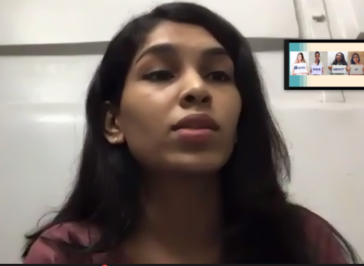
Ms. Aviva began the session by asking the participants the meaning of mental health. She then moved further by explaining the meaning of mental health and the characteristics of good as well as bad mental health. She gave us five warning signs that we must be aware of and identify in self as well as others. She emphasized on the fact that self-diagnosis is not correct and that one should always visit a psychologist in case they feel that they are suffering from any disorder. She patiently taught us the difference between terms and helped us gain knowledge. She made us understand that no one was immune to poor mental health and that it can affect anybody. She also created awareness about the different treatment options available. She cleared the air around taking medications for these disorders. She helped the students gain information about a topic that is so stigmatized in our nation. She also helped us understand the value of therapy. She normalized talking about therapy and asked us to seek help when we needed it. She also stressed on the importance of positive self-talk and how it is directly related to one’s self worth. She also focused on the importance of self-care and how important it is to develop a routine and follow it as well. She also gave us a lot of tips to deal with anxiety. She also asked us for our queries and gave her advice. She addressed each and every question and this made the session more personal. The words she said made us reflect on what we had been doing wrong. Everyone had something or the other to take from the session. She conducted the ppt very well and the slides were very simple and it she didn’t complicate such a major issue. Student Heli Sadhani proposed the formal vote of thanks for the session. The national anthem was played at the end of the session. “We rush to a doctor when we break our leg. We don’t bandage it ourselves. So why should we hide that our mind is struggling? We must seek help.” This session of BTTC was all the support we needed. It was a beautiful session and all of us had something or the other to take home from it.

Reported by: Sakshi Mehta

