WOMEN DEVELOPMENT CELL
BOMBAY TEACHERS’ TRAINING COLLEGE
A constituent college of HSNC University, Mumbai

A talkfest on
ROLE OF WOMEN IN ENVIRONMENTAL CONSERVATION

Date: 10th January, 2022
Time: 3:00 pm to 4:00 pm
Resource Person: Dr. Bharti Chhibber
Registrations: 114
Organising Secretaries: Dr. Neelu Verma & Dr. Raju Talreja
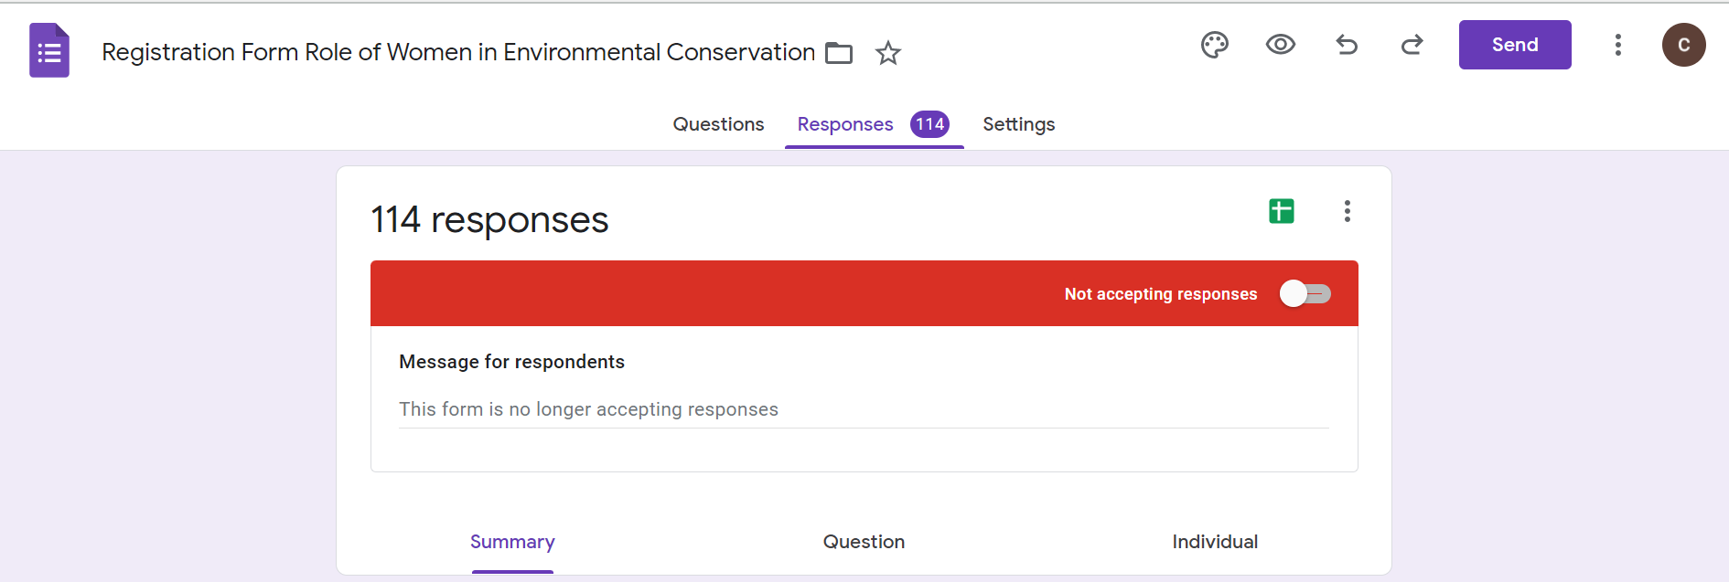
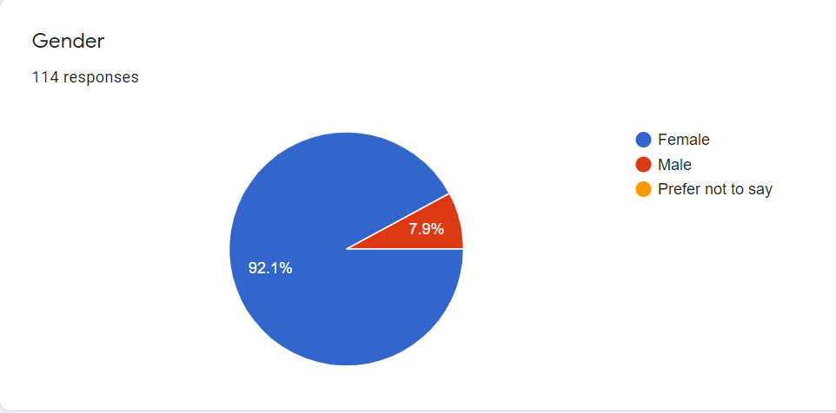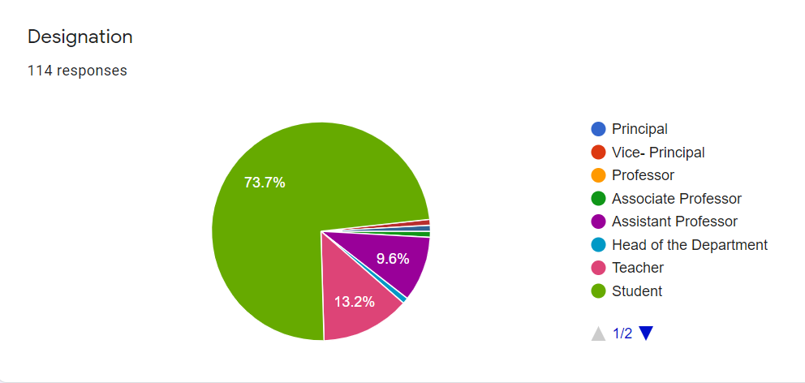
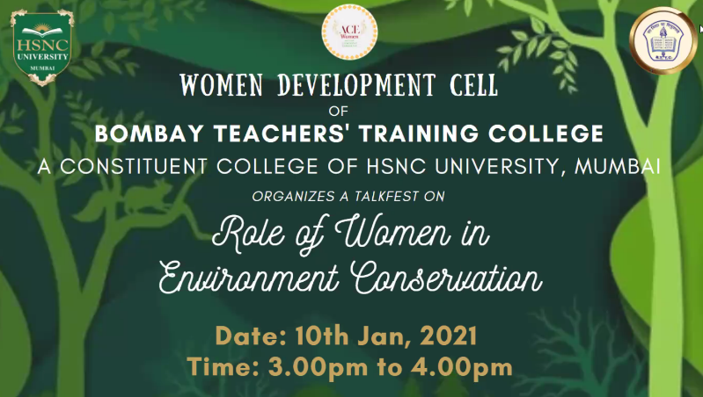
The Talkfest was commenced by Dr. Raju Talreja who elegantly advanced the session. Dr. Bhagwan Balani gave an opening remark on how women were the most important stakeholders in the area of Environmental Conversation and how they nurture not just their own children, as mother but also take care of nature and the natural environement that we all live in.
Dr. Bharti Chibber, an environmentalist, the expert for the session was introduced by Dr. Raju Talreja who put forth our speaker’s achievements and her gratitude towards Dr. Chhibber for her graceful presence.
The question and answer session was commenced by Dr. Neelu Verma who began with asking her an important question. She asked Dr. Chhibber to throw some light on the strain that growing population and technological advancements was putting on natural resources.
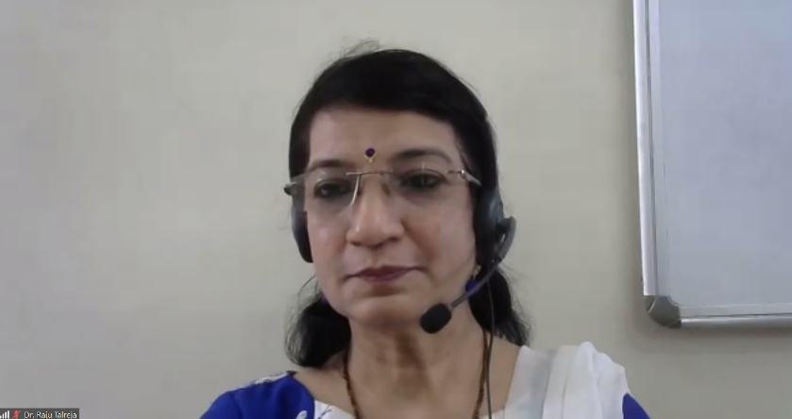
Dr. Chhibber said that environmental issues had not come up a decade or two back. In fact, it had been around since a long time. She said that development had not been sustainable and that it needs to be so now. Development should meet the needs of present without compromising the requirements of future generations. She spoke about how detrimental air pollution, green house gas emmisions and global warming could be by enlightening us about its disatrous effects.
Dr. Neelu Verma thanked Dr. Chhibber for summing up the environmental issues in a nutshell. She then spoke about how women had been continuously contributing towards environmental conservation to which Dr. Chhibber reiterated the same and asked men to come forth and fill in as the role of environmental conservators, alongside women. Women always had a stake in the process of environmental protection and sustainable development. Women were leaders in that area and played a critical role of a decision maker. Rural women also played an integral role as the same.
Neelu ma’am put forth examples of The Chipko Movement, The Green Belt Movement that played an important role in bringing out the voices of women. She then asked Dr. Chibber how these women’s movement could affect the rest of the world.
Dr. Chhibber said that globalization might have drawbacks but there are benefits. It was brought to our notice that even though women’s environmental movement are localized, their voices were reverberated globally.
On a related note, Dr. Neelu Verma requested Dr. Chhibber to give 3 ways in which one could conserve or protect the environment.
Dr. Chhibber gave an example of Tulsi Gowda who nurtured 40,000 trees, was a part of afforestation programme led by the government and a Padma Shri awardee. Planting saplings and ensuring that they grow into trees was one way an individual could protect the environment.
Next she gave the example of Almitra Pate who had filed a PIL for having a more hygenic waste management system. She was one of the members appointed to the committee of solid waste management and also one of the members who drafted India’s Municipal Soil Waste Management Plan Rules. Through this she pointed out that one should “Start at home” and segregate waste appropriately, reuse and recycle.
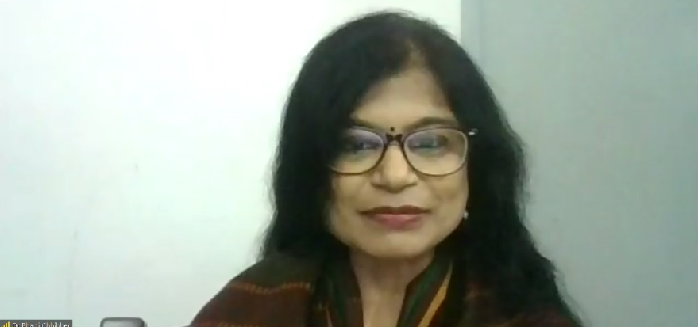
3rd eg was Rahibai Soma Popere, who started the conservation of native seeds and had a seed bank to conserve crop diversity. She too was awarded with a Padmashri Award. She directed us towards her 3rd point and urged those from rural India to use native seeds and those in urban India to utilize organic seeds.
2 examples were stated on a global level, that of Lois Gibbs from New York and Olga Speranskaya From Russia. She stated that it is important to be aware of an existing problem but equally important to raise voice against that problem.
As a response Dr. Neelu Verma elaborated on the steps or initiatives that students of BTTC had taken to help conserve the environment which may have been small but were impactful.
Dr. Neelu Verma then asked her take on environmental activism and if it was the only way to spread environmental awareness.
Dr. Chhibber mentioned that activism was not the only way one could spread awareness. She stated that dialogue is one of the most critical aspect of environmentalism and activism and it is equally important to involve men in dialogues as it is to women. She also spoke about how women involvement in decision making from the grassroot level to the highest level could make a huge difference.
She mentioned that carpooling could be a very good option to reduce environmental pollution and that there should be appropriate infrastructure such as cycling and jogging tracks which would also play a great role in curbing pollution.
Dr. Neelu Verma put forth the last question where she asked what impact do empowered women have on the entire world?
Dr. Chhibber stated that times were changing. Now, when women talk about environmental issues, people listen followed by the fact that use of natve language could be great way in which women could connect to a local community.
Before the session ended, Dr. Mandeep Kochar added that the government must take strict actions and place strategic laws to ban environmentally hazardous activities to which Dr. Chhibber replied that laws are already in place however execution and implimentation stage is where we suffer the most.
A student, Ms. Priyanka asked whether working for the environment was financially satistfying as it was personally to which she got the response that it was highly rewarding.
The main take away of this session was that action for conserving and protecting the environment should be multileveled and one must work in tandem to fullfill the dream of a cleaner and protected environment.
Lastly, Dr. Neelu Verma proposed the formal Vote of Thanks and ended the session on a positive note.

